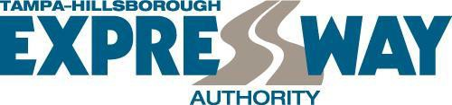

**NOTICE OF INTENDED DECISION**

**Date:** 6/22/2022

**Project:** Consultant Structures Inspection Program

RFP: O-0322

Consultant Interviews were conducted on June 7th, 2022 for the above-referenced project. Listed below is the final ranking based on the Evaluation Committees scoring:

**Firm Name Total**

|  |  |
| --- | --- |
| Burgess & Niple, Inc. | 1 |
| Kisinger, Campo & Associates, Corp. | 3 |
| MARLIN Engineering, Inc. | 2 |

The Tampa-Hillsborough County Expressway Authority staff intends to recommend approval of the ranking to the Board of Directors and request authorization to negotiate and execute a contract with the highest ranked firm. If negotiations are unsuccessful, staff shall negotiate with the next highest ranked firm. Contract is subject to review and approval of THEA General Counsel.

All notices are posted on the Authority’s website ([www.tampa-xway.com](http://www.tampa-xway.com/)) and on the DemandStar system. For questions regarding this notice, please contact the Authority's Procurement Office, [Procurement@tampa-xway.com](mailto:Procurement@tampa-xway.com%20) .

Posting Notice June 22, 2022